**History is Still Alive**

（一个美国青年的金陵寻访）

视频文字稿

姓名条：

克里斯·汉金（中文名林奎）Chris Hankin

南京大学-约翰斯·霍普金斯大学中美文化研究中心在读硕士

Master Student at the Johns Hopkins University-Nanjing University

Center for Chinese and American Studies

辛迪 Cindy Vautrin

明妮·魏特琳侄孙女

Great-niece of Minnie Vautrin

张连红 Zhang Lianhong

南京师范大学南京大屠杀研究中心主任、教授

Professor and Director of the Nanjing Massacre Research Center,

Nanjing Normal University

杨素萍 Yang Suping

南京师范大学金陵女子学院副院长

Vice President of Ginling College, Nanjing Normal University

许以眉 Xu Yimei

许传音孙女

Granddaughter of Xu Chuanyin

张庆 Zhang Qing

许传音曾外孙女

Great-granddaughter of Xu Chuanyin

中英双语字幕：

林奎：我是克里斯·汉金（中文名林奎），美国人，南京大学-约翰斯·霍 普金斯大学中美文化研究中心的在读硕士。我的曾外祖父是查尔

斯·里格斯，我想中国人可能会对他的中文名更熟悉：林查理。

Hi, my name is Chris Hankin. I'm an American, and I'm a master student at the Johns Hopkins University-Nanjing University Center for Chinese and American Studies. My great-grandfather is Charles Riggs, or as he's

known in China, Lin Chali.

林奎：当我告诉家人我要和中国的媒体谈论我曾外祖父的故事时，他

们都很好奇和兴奋，我认为这是我们家族引以为豪的一件事。

When I told my family that I was going to talk to Chinese media about his

story, they were all really excited and curious. I think that it's something

that our family is quite proud of.

林奎：2018 年，我来到中国。当时（2018 年）我还在西北工业大学

教书，如果有西北工业大学的学生正在看这个视频，你们好。

I moved to China in 2018. I taught at a university called Northwestern Polytechnical University, and if there are any students from

Northwestern Polytechnical University watching, hello!

林奎：也是在那时，我开始更多地了解南京大屠杀这段历史，以及我

曾外祖父当时做出的贡献。

And at that point, I also started to learn more about the history of the Nanjing Massacre, and also the role that my great-grandfather played in

that history.

林奎：（那时）我父母从美国来看我，随后我们一起来到南京，参观 了侵华日军南京大屠杀遇难同胞纪念馆。我们在纪念馆里四处寻找有

关曾外祖父的信息，然后我们看到了他的照片，感到非常惊讶。

So my parents came from America, and together we came here to Nanjing, and we visited the museum (The Memorial Hall of the Victims in Nanjing Massacre by Japanese Invaders). And so we were walking around, looking for information about him, and we found the photo. It

was quite surprising to find it.

林奎：我把这张照片发到微信朋友圈，当时我在西北工业大学的很多 学生回复，说他们被这段历史深深触动，这给我留下了深刻的印象。 And also, after that, I posted the photo on my social media here in China, on WeChat. A lot of my students at Northwestern Polytechnical University responded and told me that they were really moved by this

history, and that made a deep impression on me.

林奎：（上周五）我再次参观了纪念馆，我再一次去看了我曾外祖父 的照片，现在我对这段历史有了更多的了解，再次看到这张照片，我

的感受已经不同于第一次了，它对我来说有了更深刻的含义。

(Last Friday) So in this case, we visited the museum (again). I also got to go and see the photo of my great-grandfather. And now that I have learned more about the history, when I see that picture, it means more

to me.

林奎：这是《魏特琳日记》，这是中文版本的，这是英文版本的，我

最近一直在读这本书，希望能更多地了解明妮·魏特琳的故事。

Here I have Minnie Vautrin's Diary. I have a Chinese copy, and I also have an English copy. I've been reading through it to understand more about

her story.

林奎：我在这本书里看到明妮·魏特琳和我曾外祖父查尔斯·里格斯

互动的一些描述，真的很巧，这样的记述有好几次，能够更多地了解

这段历史对我来说真的很有意义。

It's been really interesting to look through and see times where Minnie Vautrin and my great-grandfather Charles Riggs interacted. I found that on a number of occasions, Minnie Vautrin's diary has stories about Charles Riggs. And so, for me, it's been really interesting to learn more

about that history.

林奎：今天我有机会和一位女士交谈，她是明妮·魏特琳的侄孙女。 Today I had the opportunity to speak with a woman, who Minnie Vautrin

was her great aunt.

林奎：我叫克里斯，你是明妮·魏特琳的？

My name is Chris, and you are Minnie Vautrin's?

辛迪：我是她的侄孙女。

I'm her great-niece.

林奎：我的曾外祖父是查尔斯·里格斯，我想，明妮·魏特琳和里格 斯当年曾在南京共事。在这里，历史依然鲜活，明妮·魏特琳给这里 的人们留下了非常非常深刻的印象。上周五我见到了一些仍在研究这

段历史的学者和历史学家，感到非常触动。人们讲述着明妮·魏特琳

的故事，不禁落泪。

My great-grandfather was Charles Riggs. I think that they worked together in Nanjing. History is still alive for people here. She made a very, very deep impression on people here. Last Friday, when I was getting to meet some scholars and historians that are still studying this period, it was very moving. People just kind of like recounting the impact she had.

People were in tears.

林奎：听到她的故事，听到她的家人谈起明妮·魏特琳以及南京大屠 杀这段历史，我感到很触动，因为在某些方面，这和我家的情况挺像

的，对于这段历史，我和家人近期也开始有些讨论。

It was really moving to get to hear her story and to hear about how her family has understood this history. Because in some ways, it was similar

to my family, where they started talking about it more recently.

林奎：（上周五）我在南京师范大学和一位学者、历史学家进行了交

谈。

(Last Friday) In the morning, we went to Nanjing Normal University, and

we spoke with a scholar there, a historian.

张连红：你的曾外祖父里格斯是南京大屠杀期间留在南京城里面的

22 个外国人之一，当时他是金陵大学的教授，主动留下来保护中国

的难民。他是南京安全区国际委员会的主要成员，在（南京）大屠杀

期间，他做了大量的工作（如为难民安排住房和筹集粮食）。

Your great-grandfather Riggs was one of 22 foreigners who stayed in Nanjing City during the Nanjing Massacre. At that time, he was a professor at University of Nanking who volunteered to protect Chinese refugees. He was also a leading member of the International Committee for the Nanking Safety Zone and did a lot of work during the Nanjing

Massacre (like arranging housing and raising food for refugees).

文字说明：2023 年 11 月 25 日，在南京有一场“感恩·南京安全区”

国际和平徒步活动，路线的起点和终点都是南京师范大学。

On November 25, 2023, the 7th International Peace Hiking was held in

Nanjing. The route started and ended at Nanjing Normal University.

从 2016 年起，今年已是第七届，为了感恩在侵华日军南京大屠杀期

间给予南京人民无私帮助的那些人。

Since 2016, the event has been held to retrace and remember every hero who selflessly aided people in Nanjing within the borders of the

Nanking Safety Zone.

杨素萍：那个时候，阁楼里面都是人（难民）。

At that time, the attic was full of people (refugees).

林奎：魏特琳是一名教师，工作中接触的很多都是中国的年轻女性。

当日本军队入侵时，她的目标是尽可能多地保护中国妇女。

Minnie Vautrin was working with the community of young Chinese women as a teacher. When the Japanese invaded, her goal was to try to

protect as many women as possible.

林奎：在这样一个美丽的地方，听到那些关于南京大屠杀的悲惨描述 和安全区庇护难民的感人故事，是一个非常强烈的对比，我觉得这也

是使我这次经历如此有影响力的原因。

It was quite a powerful contrast to be in such a beautiful place, but to be hearing such tragic and moving stories, and I think that that was part of

what made the experience so impactful.

林奎：他们（里格斯、魏特琳等人）是一群积极对这个世界付出善意 的人，他们（甚至）愿意奉献自己去帮助那些需要帮助的人，这是非

常令人钦佩的。

(Riggs and Vautrin) It was a group of people who were incredibly motivated to do good in the world, so they devoted their lives to helping

people, which is something really admirable.

林奎：（上周五）寻访的最后一站是许传音后人的家，我见到了他的

孙女和曾外孙女，许传音和我的曾外祖父里格斯在当时都是南京安全

区的工作人员。

(Last Friday) The last stop we made was, we went to the house of Xu Chuanyin, his granddaughter and great granddaughter. Xu Chuanyin and my great-grandfather Charles Riggs actually worked together in the

Nanking Safety Zone.

林奎：许传音的孙女送给了我这个礼物，这是她亲手做的，对她来说 象征着幸运。我把它放在我的房间里，这是一个非常非常暖心的礼物。 His granddaughter gave me this, which is something that she made and for her it signified luck. And so now I keep it in my room and I think it's a

really, really sweet gift.

林奎：我的姨祖母今年 94 岁，现在在美国，她是在南京出生的，在 南京度过了人生最初的几年。最近我一直在和她沟通，她给了我更多 的材料，让我从家族史的角度来更好地了解南京大屠杀的历史。看到 中国人现在仍然非常重视这段历史，仍然非常想了解我曾外祖父的故

事，她感到非常兴奋，因为对她来说这是有点私人的故事。

My great aunt is gonna be 94 this year. She lives in America, and she was born in Nanjing, and lived the first few years of her life in Nanjing. So recently I've been communicating with her, and she has been sending me more resources to learn about the history from our family's side. And

I think that it's been really exciting for her to see that people in China still

really value this history, and still really want to know more about this

history. Because for her it's quite personal.

林奎：稍等，我看到了我的两个同学，我得和他们打个招呼。

Wait, I'm sorry, really quickly. I think two of my classmates are here.

林奎：我和我的中国同学聊起过我曾外祖父的故事和那段历史，他们 都深受触动，这让我十分感动。当我和我的美国朋友聊起这些时，他 们都非常非常惊讶，向他们讲述我的家族史，其实也给了我一个机会 讲述更多关于二战的这一部分（南京大屠杀），他们之前对此可能不

太熟悉。

It's always interesting to tell people, especially Chinese classmates, about my great-grandfather and about the history. Because typically they respond really positively. When I tell American friends about this, they are often very, very surprised. And so oftentimes when I tell them about my personal family history, it's also an opportunity to tell them a little bit more about this other part of World War II history that they might not be

quite so familiar with.

林奎：每当我向人们讲述那段历史和我曾外祖父做出的贡献时，我都 感到很自豪，因为我觉得这是一种不分国籍 向他人提供帮助的优秀

传统，这种传统我想一直延续下去。

I think that whenever I get to tell people about the history and about the role that my great-grandfather played, I feel a little bit proud. Because I feel as though it's a tradition and a legacy that I want to try to follow in,

this tradition of helping others regardless of national background.

林奎：我很想告诉我的曾外祖父，现在的中国和他当时生活的中国相 比有多么大的变化。2023 年来到中国，至少在南京这样的城市，你 能看到一个强大的国家，现在中国的模样与他当年在这里看到的大不

一样了。

I really want to tell my great-grandfather and describe how much China has changed since he was here. Coming to China now in 2023, at least in cities like Nanjing, you see a very, very developed and economically powerful country, and it's very very different from the country that he

would have seen when he was here.

注释：

查尔斯·里格斯（前排中）

Charles Riggs (first row middle)

资料：《魏特琳日记》

File: Diary of Wilhelmina Vautrin, 1937-1940

资料：约翰·马吉拍摄影片

File filmed by John G. Magee

明妮·魏特琳（前排左三）

Minnie Vautrin (first row left 3)

约翰·马吉（后排左三）

John G. Magee (rear row left 3)

1938 年 1 月 15 日，里格斯写给妻子的信

Letter written from Riggs to his wife on January 15, 1938

资料：1937 年 12 月 19 日《纽约时报》

File: The New York Times, December 19, 1937.

**History is Still Alive**

（一个美国青年的金陵寻访）

二维码



**History is Still Alive**

（一个美国青年的金陵寻访）

首发界面全屏截图

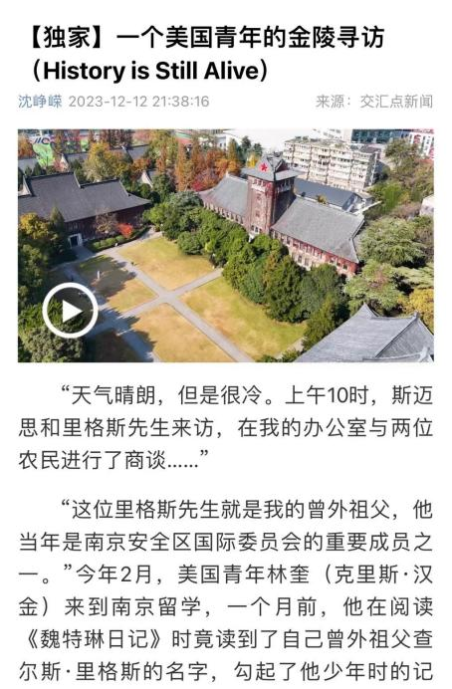

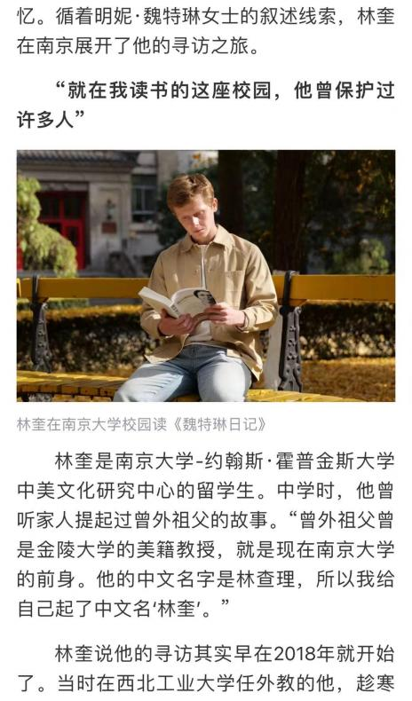

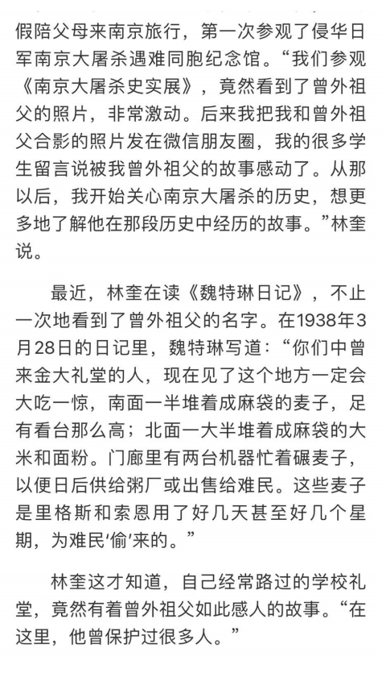

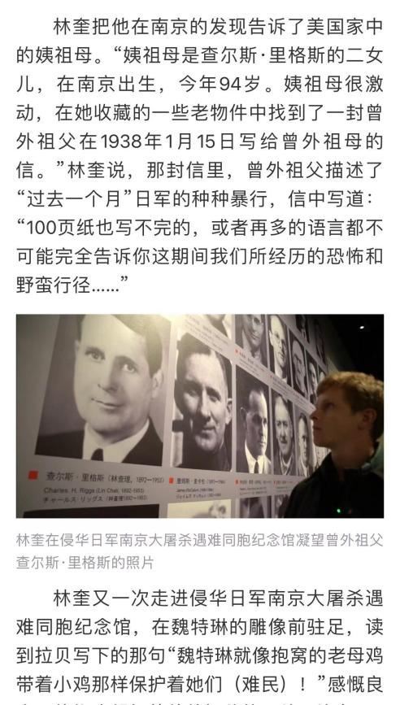

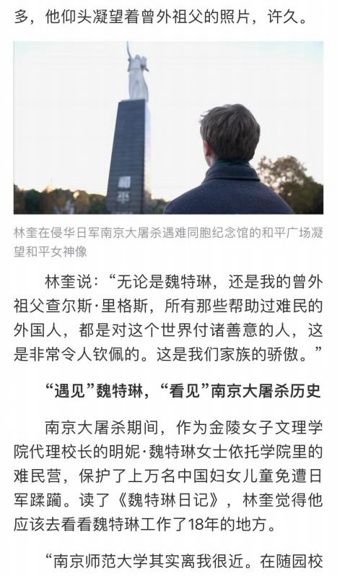

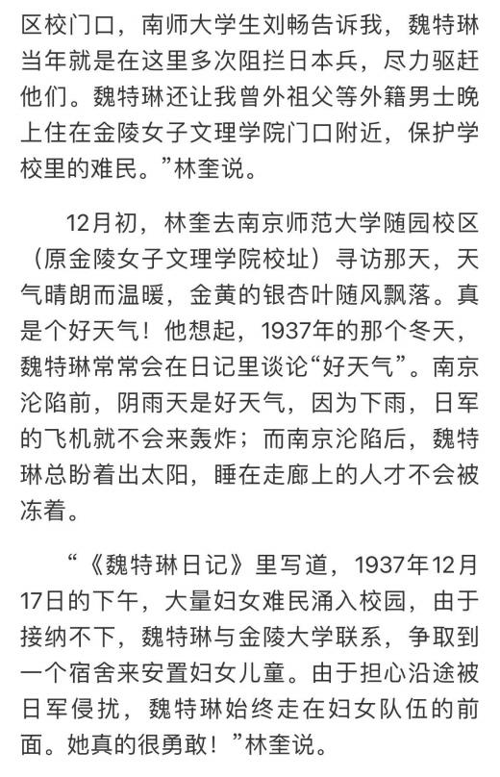

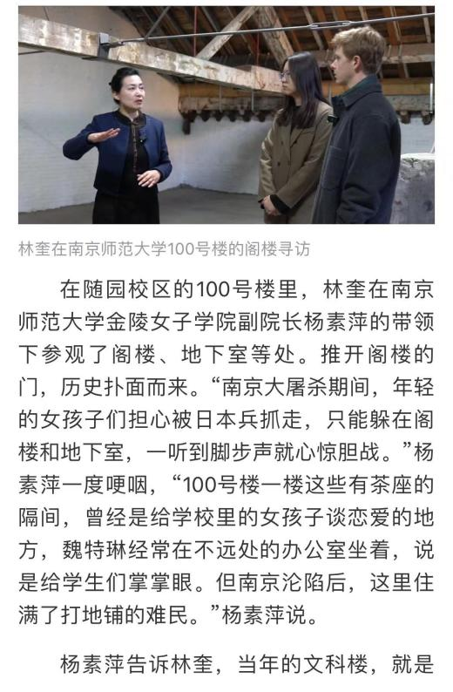

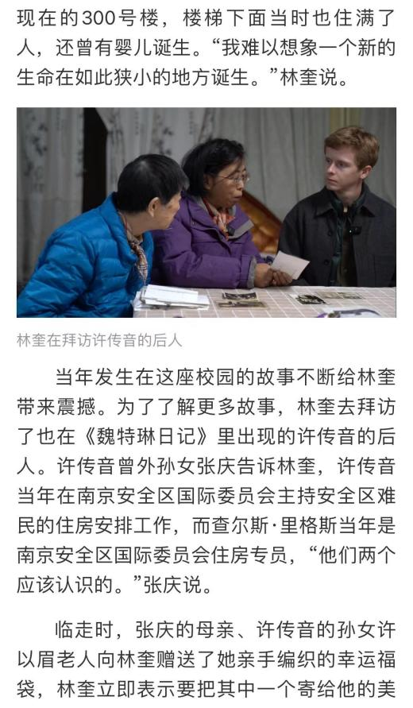

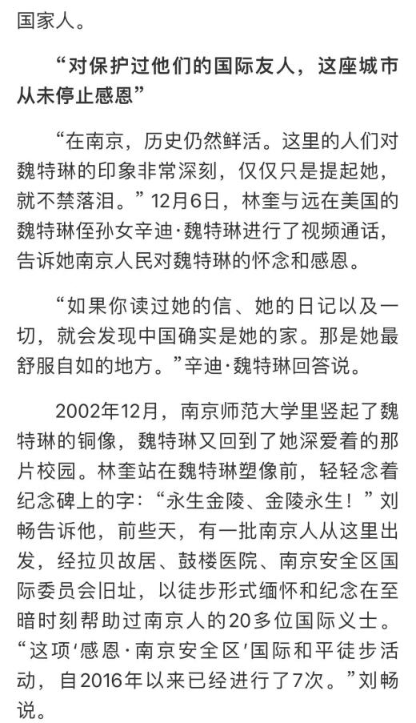

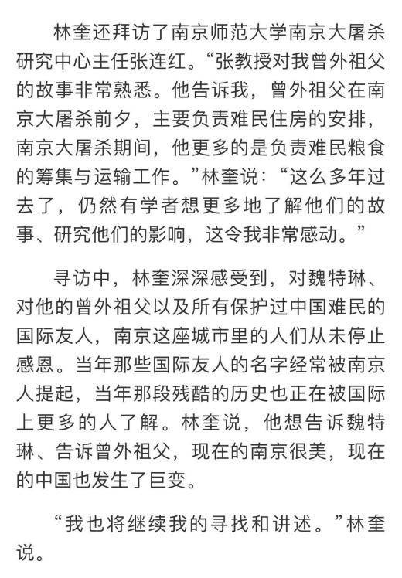

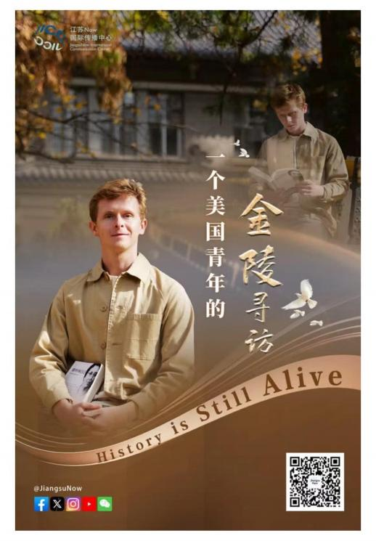

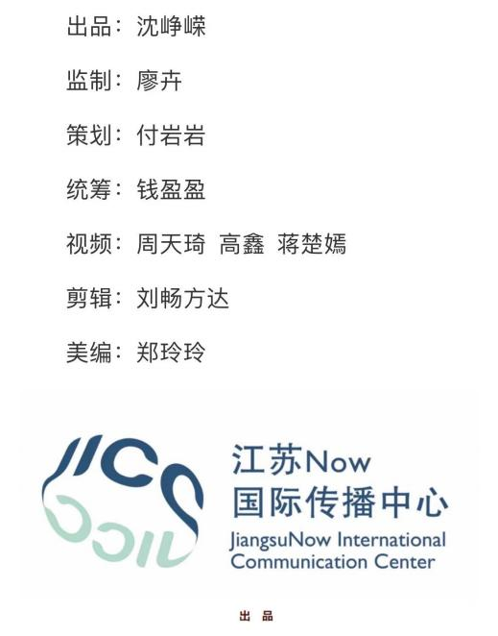

国际传播参评作品推荐表

|  |  |  |  |  |  |  |  |  |  |  |  |  |  |
| --- | --- | --- | --- | --- | --- | --- | --- | --- | --- | --- | --- | --- | --- |
| 作品标题 | | History is Still Alive  （一个美国青年的金陵寻访） | | | | 体 裁 | 新闻专题 | | | | | | |
| 作 者  （主创人员） | | 集体（沈峥嵘、廖卉、付岩岩、钱盈盈、周天琦、高鑫、蒋楚嫣、刘畅方达、郑玲玲） | | | | 编 辑 | 顾雷鸣 | | | | | | |
| 原创单位 | | 新华日报社 | | | | 发布端/账号/媒体名称 | 交汇点 | | | | | | |
| 字数/时长 | | 7分29秒 | | | | | 语种 | | | | 中英双语 | | |
| 刊播版面(名称和版次) | |  | 刊播日期 | | | 2023年12月12日 | | | | | 刊播  周期 | |  |
| 新媒体作品填报网址 | | <https://jhd.xhby.net/share-webui/detail/s6578624ae4b0bf57eca9534c>  交汇点二维码 | | | | | | | | | | | |
| ︵  作采  品编  简过  介程  ︶ | | 2023年，中美元首会晤期间，国家主席习近平发表重要演讲，强调“中美关系的故事是由人民书写的”。在第十个南京大屠杀死难者国家公祭日前夕，新华日报社独家推出《History is Still Alive（一个美国青年的金陵寻访）》中英双语微纪录片。作品真实记录南京安全区国际委员会重要成员里格斯的曾外孙、美籍青年留学生克里斯（中文名：林奎）的金陵寻访经历，在传统题材中注入“中美关系”年度新闻新要素，讲述由中美人民“浇灌”的过往、当下与未来。  该作品发布24小时内即获全网推送，是公祭日报道中唯一，全网累计传播量已逾30亿。  林奎的寻访凸显三大主线：了解曾外祖父里格斯的故事以及当年南京安全区国际委员会帮助中国难民的历史；感知侵华日军南京大屠杀暴行对中国民众的伤害；感动于中国人民至今对国际义士当年救助的深深感恩。  2023年11月底，主创团队第一时间联系到林奎，真实记录他的自主寻访与主动叙事，最终成片客观真实且有感染力，实现“他者”完整叙事，也实现南京大屠杀史实由海外人士主动向西方世界深度讲述、广泛传播的新维度。作品发布后，众多海内外网友自发留言，表达对南京安全区国际委员会成员的致敬、对国际义士当年救助中国难民的深深感恩，感动于中美人民友好交往的延续。 | | | | | | | | | | | |
| 国  际  传  播  效  果 | | 该作品打破传播壁垒，有力传播并加深了西方世界对南京大屠杀史实的全面认知。  作品在海外实现多语种传播和主要社交媒体平台的全覆盖，国际传播影响力大。捷克24小时门户新闻网进行捷克语传播，中希时报门户网进行希腊语传播；X、脸书、照片墙、Tik-Tok等平台累计触达和互动人次逾300万；美国《侨报》、《欧洲时报》等对外华文媒体及新媒体平台，华人头条广泛传播。  海外有影响力人士主动关注作品内容，欧美民众积极转发。圣母大学副教授Joshua Eisenman主动转发留言，国际友人拉贝、马吉和布莱迪医生后人以及法国著名画家帕赫点赞转发留言。（境外落地情况详见附页）  该作品发布后，国际传播影响力持续扩大，社会价值持续凸显。在《Echoes of History（一个美国青年的金陵寻访后续）》报道中，林奎表示他与中国朋友们增进了交流了解，他的美国朋友们表示也想去了解这段历史，他和他的家人都愿意继续为传播这段历史做贡献。  该作品还首度公开了里格斯于1938年1月写给妻子的家书。信中，里格斯主要记载了1937年12月至1938年1月期间他在南京的见闻和感受，多次提到侵华日军南京大屠杀期间的悲惨情景。经专家认定，这封信进一步佐证了震惊中外的南京大屠杀暴行，属于南京大屠杀史料中的第三方史料，是一份非常重要的文献。 | | | | | | | | | | | |
| ︵  初推  评荐  评理  语由  ︶ | | 签名：  （盖单位公章）  2024年 月 日 | | | | | | | | | | | |
| 联系人 | 沈峥嵘 | | 邮箱 | bread999@163.com | | | | | 手机 | | 13851824704 | | |
| 地址 | 江苏省南京市建邺区江东中路369号 | | | | | | | | 邮编 | | 210092 | | |
| 以下仅自荐、他荐参评作品填写 | | | | | | | | | | | | | |
| 自荐作品所获  奖项名称 | | 2023年度江苏省好新闻（媒体融合）一等奖  2023年度江苏省对外宣传工作创新奖提名奖 | | | | | | | | | | | |
| 推荐人姓名 | | 钱丽萍 | 单位及职称 | | 新华日报社副总编辑  高级编辑 | | | | 电话 | | | 13901580689 | |
| 推荐人姓名 | | 方晖 | 单位及职称 | | 江苏省记协秘书长  高级编辑 | | | | 电话 | | | 18936875084 | |
| 联系人姓名 | | 沈峥嵘 | 手机 | | 13851824704 | | | 电话 | | 025-58680335 | | | |
| 推荐理由及  推荐人意见 | | 区别于传统“我要说”，这部国际传播作品突出“他想知”。原动力、主动探寻者是美国青年林奎，“历史依然鲜活”是林奎的感受，也是整部作品的三重线索与丰富内涵，更符合国际传播“他者”视角，林奎也成为主动向西方的传播者，极大增强可信度影响力，体现对外传播实效与国别精准传播。（钱丽萍）  2023年，“中美关系”成为本年度重要新闻关键词。这部作品在第十个南京大屠杀死难者国家公祭日前夕推出，通过美国青年留学生林奎对家族记忆的追溯，串联起对中美人民友好交往历史的追溯，是一件对传统题材注入年度新闻要素的国际传播创新优秀作品。（方晖）  推荐人（两名）签名：自荐、他荐人签名：  2024年 月 日 2024年 月 日 | | | | | | | | | | | |
| 审核单位意见 | | （加盖单位公章）  2024年 月 日 | | | | | | | | | | | |